**Double-end pumped efficient MHz self-mode-locked Pr:YLF green and red lasers**

**Saiyu Luo, Bin Xu, Huiying Xu, Zhiping Cai1,\***

*Department of Electronic Engineering, Xiamen University, Xiamen 361005, China*

*\*E-mail:* [xubin@xmu.edu.cn](mailto:xubin@xmu.edu.cn), zpcai@xmu.edu.cn

**Abstract:** We demonstrate an efficient tens and hundreds of MHz self-mode-locked green and red lasers in a Pr3+:YLF4 crystal with V-type and Z-type cavity using a double-end-diode-pumped structure without the need of any additional components. Thanks to the double-end pumped scheme, with an absorbed pump power of ~2.8 W, more than 0.68 W average output power operating in the cw mode locked state with a slop efficiency of 29.9% with respect to the absorbed pump power for 522 nm green laser and more than 1.44 W with a slop efficiency of 57.3% for 639 nm red laser were obtained. The output pulse trains and power spectrums demonstrate steady mode-locked operations at the maximum output power for hours. The spectral width (FWHM) of the 639 nm self-mode-locked operation with an effective cavity length of 1.61 m was measured to be 0.39 nm, indicating a transform-limited pulse width of 808 fs assuming sech2-shaped temporal profile.

**Keywords:** Solid state laser, Blue diode-double-end pump, Pr:YLF crystal,visible laser source, (140.4050) Mode-locked lasers; (190.3270) Kerr effect.

**1. Introduction**

**2. Experimental Set-Up**

Figure 1 depicts the experimental setup for the self-mode-locked Pr:YLF red laser with a repetition rate of ~85 MHz using a double-end pumping scheme. The cavity configuration is a Z-type resonator with a total cavity length of ~1.8 m. The active medium is an a-cut 0.2 at. % Pr3+:YLF4 crystal with a length of ~8 mm. Both end surfaces of the Pr3+:YLF4 crystal were plano and uncoated. The laser crystal was wrapped with indium foil to improve the thermal contact and mounted in a water-cooled copper holder. The water temperature was maintained around 18°C to eliminate thermal effect. The laser crystal was placed close to IM1, which is the input mirror for the pump on the left side. IM2 is the input mirror for the pump on the right side and was tilted with respect to the pump to make the cavity longer. Both IM1 and IM2 had high transmission (>95%) at ~444 nm and high reflection (>99.8%) at 639 nm.

Each of the two pump sources is a commercially available ~1.8 W, ~444 nm single-mode LD with achromatic and collimation systems. By using single-mode diode pumping, sufficient self-focusing (which may result in self-mode-locking) could be expected owing to the relatively smaller cavity mode size, since single-mode diode pumping tends to induce single-mode laser oscillation.

Focusing lenses with 50 mm focal length was used to inject the pump beam into the laser crystal with an average pump size of approximately 60 μm, which is measured by using Spiricon M2-200.

HR1~HR3 were concave mirrors with radius of curvature of 300 nm and had high reflection (>99.7%) at 639 nm, which could provide positive feedback for 639 nm lasing. The output coupler (OC) was a coated plane mirror with a transmission of 3.5% at 639 nm. The distance between IM1 and IM2 plus the distance between IM2 and HR1 equals ~300 mm. The distance between HR1 and HR2 and the distance between HR2 and HR3 were both around 600 mm. The distance between HR3 and OC was ~300 mm.

Theoretically, taking all these distances into account, the total cavity length was ~1.8 m.

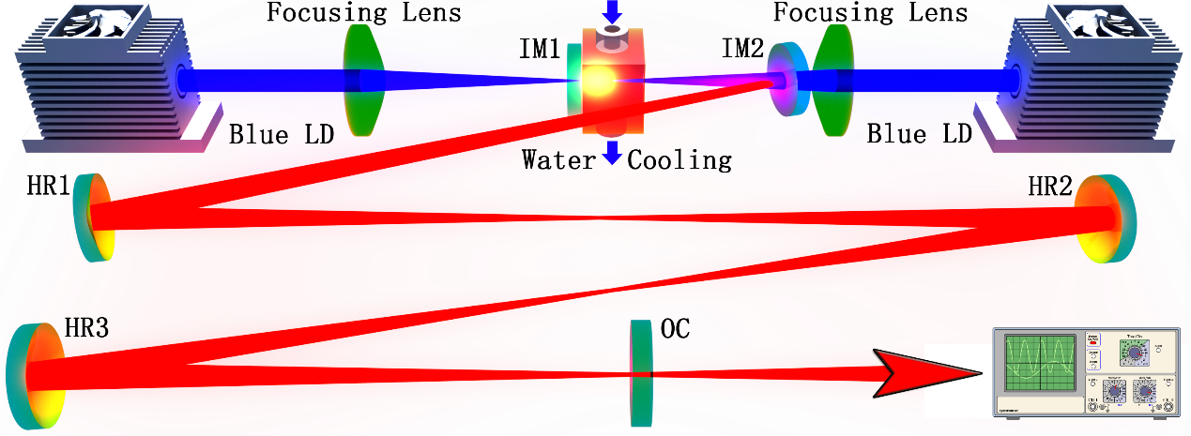

Fig. 1. Schematic of the Z-type self-mode-locked Pr3+:YLF4 red laser.

Moreover, for 639 nm self-mode-locked lasing operation, experiments with a V-type cavity and concave OC with a radius of curvature of 300 mm was conducted, making the cavity length ~0.3 m. The same V-type schematic using different IMs and OC for 522 nm lasing was also used to generate green self-mode-locked laser. For the 522 nm self-mode-locked laser, the two input mirrors IM1 and IM2 had a high transmission (> 95%) for the pump (~444 nm), high reflection (> 99.9%) at 523 nm to support lasing and high transmission (> 60%) around 607 and 639 nm to suppress the high gain emissions at those wavelengths. The concave output coupler had a radius of curvature of 300 mm and transmission of 1.9% at 522 nm.

**3. Experimental results and discussions**

For the Z-type cavity with a total cavity length of ~1.8 m shown in Figure 1 operating at 639 nm, the optical cavity length was firstly set to be approximately 1.8 m, corresponding to a FSR of 83.3 MHz. Than the cavity length and alignment was optimized for generating the maximum average output power. The time trace of the output radiation revealed the laser to be operating in the self-mode-locked state. Thanks to the double-end pumping scheme, more than 1.44 W output power was extracted with a total laser slop efficiency of 57.3% with respect to the absorbed pump power. In the experiment, the left and right pump LDs were turned on in turn. The lasing performance for ~1.8 m Z-type cavity operated in self-mode-locked state at the wavelength of 639 nm was shown by the red dots and line depicted in Figure 2.

For the green self-mode-locked Pr3+:YLF4 laser operating at the wavelength of 522 nm, which adopted a ~0.3 m V-type cavity using OC with a transmission of 1.9%, owing to the double-end pumping scheme, up to ~0.68 W average output power at mode-locked state was obtained, with a total laser slop efficiency of 29.9% with respect to the absorbed pump power as shown by the green dots and line sketched in Figure 2.

The reason why we did not manage to extend the cavity length of the green self-mode-locked laser might result from the fact that the green laser is more susceptible to the air conditions, which might limit the transmitting distance in the atmosphere, especially when considering intra-cavity transmitting.

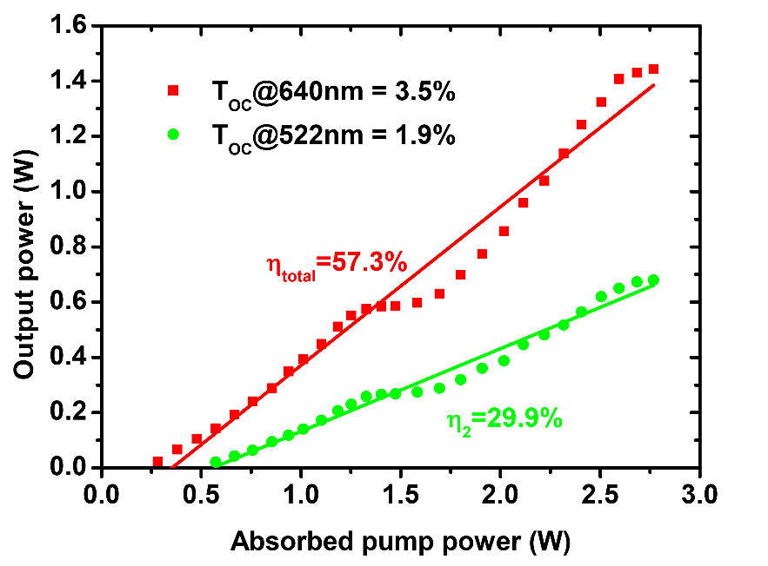

Fig. 2. Self-mode-locked laser performance of the ~1.8 m cavity 639 nm (red) and ~0.3 m 522 nm (green) laser operations.

It is worth noting that the flat points at the absorbed pump power of 1.4~1.6 W shown in Figure 2 were caused by the introduction of double-end pumping scheme and the way we record the input-output relation, which is by first turning one pump to maximum and then another. Another notable feature for the laser performance is that the double-end pumping scheme could lead to a larger slop efficiency compared with individual pumping, which might belong to the increased overlapping efficiency that the pump interacts with laser cavity modes when two pump beams were injected from both ends.

The optical spectrum of the ~1.8 m cavity 639 nm laser operated in self-mode-locked state was shown in Figure 4. The spectrum was registered by Hewlett Packard 8560E Series Optical Spectrum Analyzer with a resolution of 0.08 nm under maximum pump power and meanwhile, a photo detector and digital oscilloscope was used to monitor the laser output to ensure that the laser was operated in mode-locked state. As shown in Figure 4, the center wavelength was 639.4 nm, and the spectral width (FWHM) was measured to be 0.39 nm, which corresponded to a transform-limited pulse width of 808 fs assuming sech2-shaped temporal profile. In fact, the measured spectrum shows some internal structures. Generally, the longer the cavity, the more longitudinal mode that oscillates in the cavity, the more stable if mode-locked.

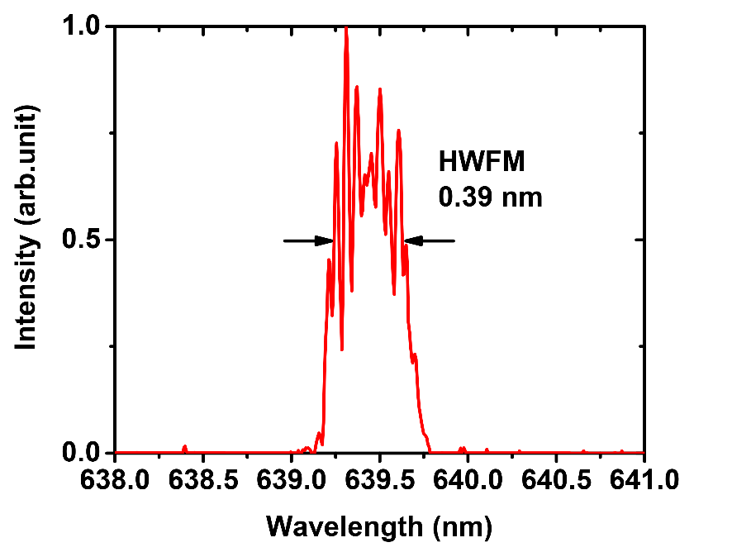

Fig. 3. Optical spectrum of the self-mode-locked Pr3+:YLF4 laser for 639 nm at cavity length of ~1.8 m measured at the maximum pump power.

The mode-locked pulses trains were detected by a free space high sensitivity PIN photo detector unit (Menlo Systems, Inc. FPD310-FV with rise time 0.7 ns), whose output signal was connected to a digital mixed signal oscilloscope (Tektronix MSO 3054) with 500 MHz electrical bandwidth and a sampling interval of 0.4 ns.

Figure 4 shows the pulse train results measured from the output of one of the high reflection mirrors (HR1~HR3) or IM2 at the same time the maximum emitting laser powers from output coupler (OC) were measured. This has the advantage of both ensuring that the lasers were in mode-lock state while optimizing output power, and protecting the photo detector by letting few energies hit on it.

Figure 4 shows the pulse trains for the self-mode-locking operated at the wavelength of 522 nm (Figure 4(a), Figure 4(d)) and 639 nm (Figure 4(b), Figure 4(e)) with a cavity length of ~0.3 m, and the self-mode-locking pulse trains at the wavelength of 639 nm with a cavity length of ~1.8 m (Figure 4(c), Figure4(f)), respectively, on two different time scales.

The figures on the left side of Figure 4 are the ones with time span of 200 ns, demonstrating mode-locked pulses, and the figures on the right side of Figure 4 are the ones with time span of 40 μs, demonstrating the amplitude stability. It can be seen that the pulse trains display full modulation, and the complete mode locking is achieved. In fact, the stable mode-lock oscillation could be maintained for a few hours at the maximum output power without changes of the output characteristics.

Unfortunately, the sampling rates of our photo detector and digital oscilloscope were not sufficient enough to detect the details of the pulse trains and the single pulse traces could neither be depicted, because the auto-correlation function analyzer in our lab was not available in the visible spectral range.

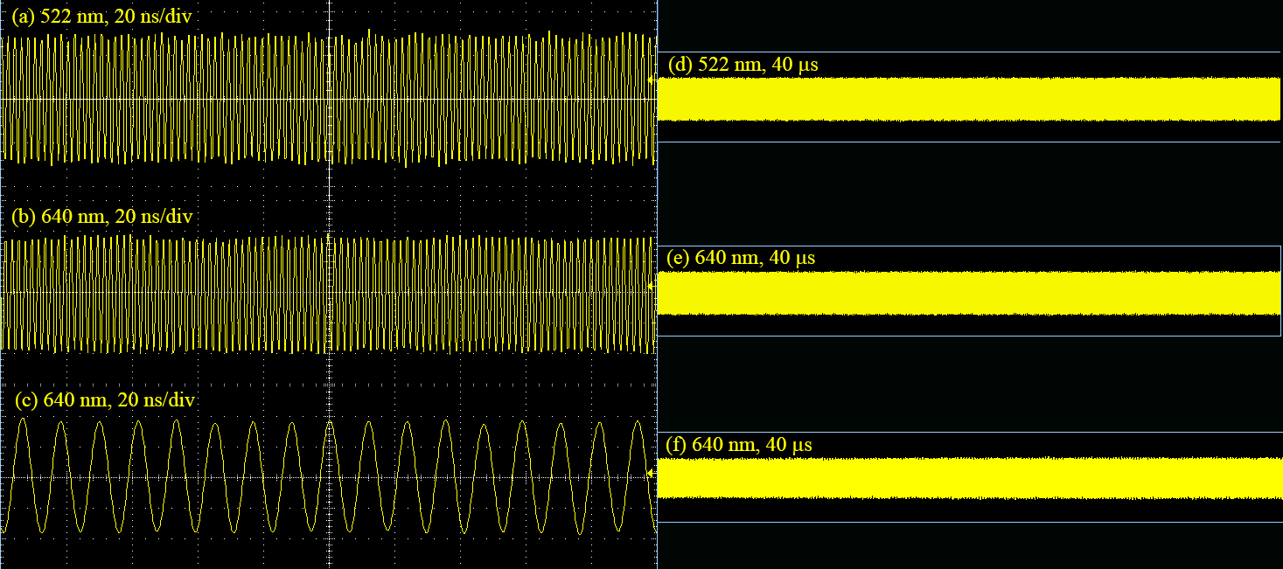

Fig. 4. Output pulse trains of the self-mode-locked lasers operating at the wavelength of 522 nm and 639 nm with a cavity length of ~0.3 m ((a), (b), (d), (e)) and ~1.8 m ((c), (f)) in time span of 200 ns ((a), (b), (c)) and 40 μs ((d), (e), (f)).

It deserves noting that once the lasing threshold is reached by appropriately adjusting the laser cavity, the laser system steps into a stable mode-locked operation instantaneously, with no need of any mechanical perturbation. The locking mechanism is presumed to be the Kerr effect. Nonetheless, the laser system has high stability over day-long operation and is immune to mechanical vibrations and air condition. As a result, some auxiliary mechanism seems to exist in the locking process. Bai et al. [Novel self-mode-locking mechanism in narrow-band lasers] proposed a novel self-mode-locking mechanism in narrowband lasers based on the analysis of the gain-line splitting induced by an intra-cavity laser field. Although the present experimental results are fairly consistent with this mechanism, it still remains an open question and needs further identification.

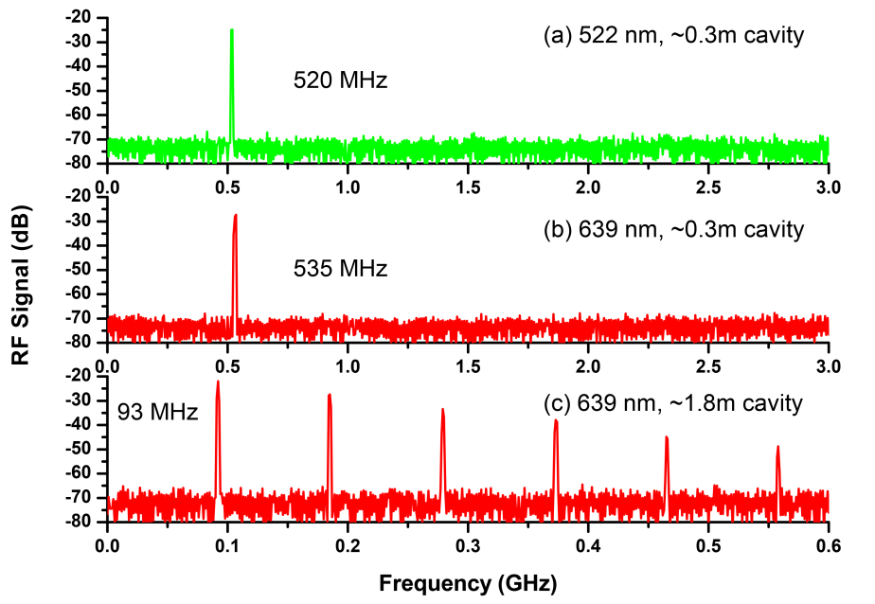

Fig. 5. Power spectrum of the self-mode-locked lasers operating at the wavelength of 522 nm and 639 nm with a cavity length of ~0.3 m ((a), (b)) and ~1.8 m ((c))

The power spectrum of the mode-locking outputs were detected by the same free space high sensitivity PIN photo detector unit as the one used for mode-locked pulse train measurement, whose output signal was transferred to an rf spectrum analyzer (GωINSTEK, GSP-930) with a bandwidth of 3.0 GHz. The results shown in Figure 5 were also recorded through one of the three high reflection mirrors (HR1~HR3) or IM2 when maximum output powers were achieved.

As is depicted in Figure 5(a), repetition rate of 520 MHz was registered for self-mode-locked laser operating at the wavelength of 522 nm using V-type cavity and OC with radius of curvature of 300 mm, indicating an effective cavity length of 288 mm when the cavity was optimized for the maximum output power.

What’s more, by introducing the same V-type cavity and the same radius of curvature of 300 mm for the OC, but switching cavity mirrors for the 639 nm laser emitting, repetition rate of 535 MHz was recorded for the self-mode-locked laser operating at the wavelength of 639 nm as shown in Figure 5(b), deducing an effective cavity length of 280 mm when the maximum output power was achieved.

The reason why the cavity length optimized for maximum average output power for the 522 nm self-mode-locked laser was calculated to be longer than that of 639 nm is interesting. It might be explained as follows.

The 522 nm emission was generated from the so-called thermal coupled 3P­J and 1I6 multiplets to 3H5 energy level, which is right above the ground state energy level 3H4 and therefore forms a quasi-three energy level system [Red-luminescence analysis of Pr3+ doped fluoride crystals] which might benefit from moderate heating by increasing the population of the upper energy level and decreasing the population of the ground state energy level of the transition, thus facilitating the population inversion of the system. While on the other hand, the 639 nm emission corresponds to a typical four level energy system, for which mitigating thermal effects is more favorable as for improving lasing efficiency, especially for mode-locked laser operations, with which the peak power would rise by many orders of magnitude compared with that of continuous wave operation (roughly the ratio of cavity round-trip time to the final pulse width, assuming a constant pulse energy. For a 93 MHz, 808 fs laser, which is the transform-limited pulse width calculated from spectral width, this is a factor of 8.7×107), leading to a more severe thermal loading.

To be specific, for our V-type laser cavity, the longer the effective cavity length (the resonator configurations should be guaranteed to be in the stable state), the smaller the intro-cavity mode sizes, the more thermal load it generates [Pump-to-mode size ratio dependence of thermal loading in diode-end-pumped solid-state lasers], leading to more heat production, which results in a more efficient lasing for 522 nm self-mode-locking operation, and vice versa for the 639 nm laser emission, as explained above. That could explain why, considering the same cavity scheme, a shorter effective cavity length for self-mode-locked operation at 639 nm, compared with that of 522 nm, was obtained to achieve the best laser performance.

Besides, regarding the ~1.8 m Z-type cavity operating in self-mode-locked state at the wavelength of 639 nm, the corresponding power spectrum is plotted in Fig. 3(c), which shows five harmonic frequencies with the fundamental repetition rate of 93 MHz, demonstrating an excellent stability of the self-mode-locking operation to some extent. The fundamental resonance frequency of 93 MHz reveals an effective total cavity length of 1.61 m when maximum average output power was achieved.

As is demonstrated in Figure 5, the lasers were cw mode locked with only weak noise, the signal to noise ratio of the fundamental resonance frequency was experimentally found to be approximately 42 dB.

**4. Conclusion**

In this paper, an efficient tens and hundreds of MHz self-mode-locked green and red lasers in a Pr3+:YLF4 crystal with V-type and Z-type cavity using a double-end-diode-pumped structure without the need of any additional components was demonstrated. Thanks to the double-end pumped scheme, with an absorbed pump power of ~2.8 W, more than 0.68 W average output power operating in the cw mode locked state with a slop efficiency of 29.9% with respect to the absorbed pump power for 522 nm green laser and more than 1.44 W with a slop efficiency of 57.3% for 639 nm red laser were obtained. The output pulse trains and power spectrums demonstrate steady mode-locked operations at the maximum output power for hours. The spectral width (FWHM) of the 639 nm self-mode-locked operation with an effective cavity length of 1.61 m was measured to be 0.39 nm, indicating a transform-limited pulse width of 808 fs assuming sech2-shaped temporal profile.

**Acknowledgments**

The authors wish to acknowledge the financial support from the National Natural Science Foundation of China (61275050, 61605069), National key Research and Development Program of China (2016YFB0701002).

**References**

[Nonlinear refractive indices of disordered NaT(XO4)2 T=Y, La, Gd, Lu and Bi, X=Mo, W femtosecond laser crystals]. A. García-Cortés, M. D. Serrano, C. Zaldo, C. Cascales, G. Strömqvist, and V. Pasiskevicius, “Nonlinear refractive indices of disordered NaT(XO4)2 T=Y, La, Gd, Lu and Bi, X=Mo, W femtosecond laser crystals,” Appl. Phys. B 91, 507-510 (2008).

[Novel self-mode-locking mechanism in narrow-band lasers]. Y. Bai, S. Chen, Z. Wang, and G. Zhang, Appl. Phys. Lett. 63, 2597 (1993).

[SESAM mode locked red praseodymium laser]. M. Gaponenko, P. W. Metz, A. Härkönen, A. Heuer, T. Leinonen, M. Guina, T. Südmeyer, G. Huber, and C. Kränkel, “SESAM modelocked red praseodymium laser,” Opt. Lett. 39, 6939–6941 (2014).

[Red-luminescence analysis of Pr3+ doped fluoride crystals] S. Khiari, M. Velazquez, R. Moncorge, J.L. Doualan, P. Camy, A. Ferrier, M. Diaf, J. Alloys Compd. 451 (2008) 128–131

[Pump-to-mode size ratio dependence of thermal loading in diode-end-pumped solid-state lasers]. Y. F. Chen, “Pump-to-mode size ratio dependence of thermal loading in diode-end-pumped solid-state lasers,” J. Opt. Soc. Am. B 17(2000) 1835.

[Theory of passive additive-pulse mode locking].

[Additive pulse mode locking]. E. P. Ippen, H. A. Haus, and L. Y Liu, “Additive pulse mode locking,” J. Opt. Soc. Am. B 6, 1736 (1989).

[SESAM mode-locked red praseodymium laser]. Maxim Gaponenko, Philip Werner Metz, Antti Härkönen, Alexander Heuer, Tomi Leinonen, Mircea Guina, Thomas Südmeyer, Günter Huber, and Christian Kränkel, “SESAM mode-locked red praseodymium laser,” Opt. Lett. 39(24), 6939 (2014)

[Kerr-lens mode-locked visible transitions of a Pr:YLF laser]. S. Ruan, B. H. T. Chai, J. M. Sutherland, P. M. W. French, and J. R. Taylor, “Kerr-lens mode-locked visible transitions of a Pr:YLF laser,” Opt. Lett. 20, 1041–1043 (1995).

[Self-starting Kerr-lens mode-locked femtosecond Cr4+:YAG and picosecond Pr3+:YLF solid-state lasers]. Y. P. Tong, A. V. Shestakov, B. H. T. Chai, J. M. Sutherland, P. M. W. French, and J. R. Taylor, “Self-starting Kerr-lens mode-locked femtosecond Cr4+:YAG and picosecond Pr3+:YLF solid-state lasers,” Opt. Lett. 21, 644–646 (1996).

[Pr3+:YLF mode-locked laser at 640 nm directly pumped by InGaN-diode lasers]. KODAI IIJIMA, RYOSUKE KARIYAMA, HIROKI TANAKA, AND FUMIHIKO KANNARI, “Pr3+:YLF mode-locked laser at 640 nm directly pumped by InGaN-diode lasers,” Applied Optics 55(28), 7782 (2016)